**Test Document for Finalization option in Purchase Order Invoice Processing**

Test Document for finalize button

IR no – 680213

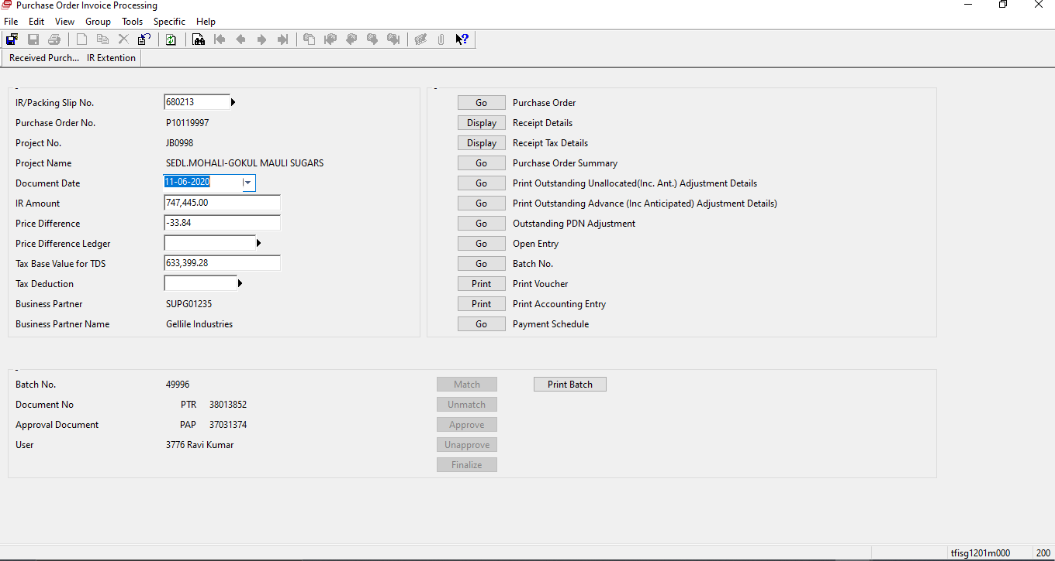

Batch – 49996 is already finalized, So button is disable.

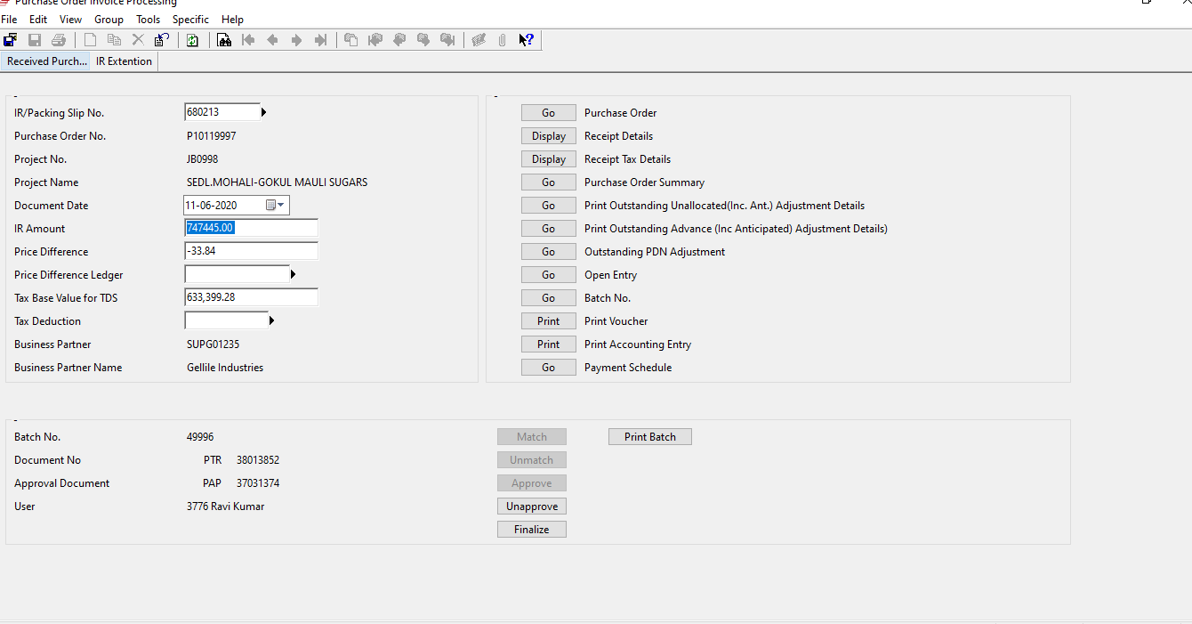

New batch which ready enabled the button.

